Price Hike Control

Color Palette:

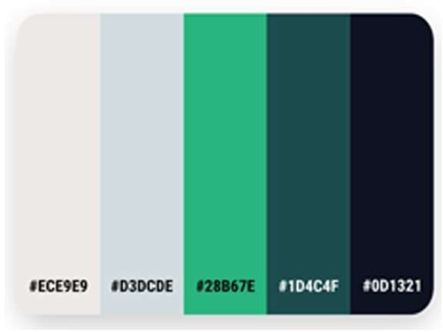

Due to Government Projects color palette chosen as Green Shade.

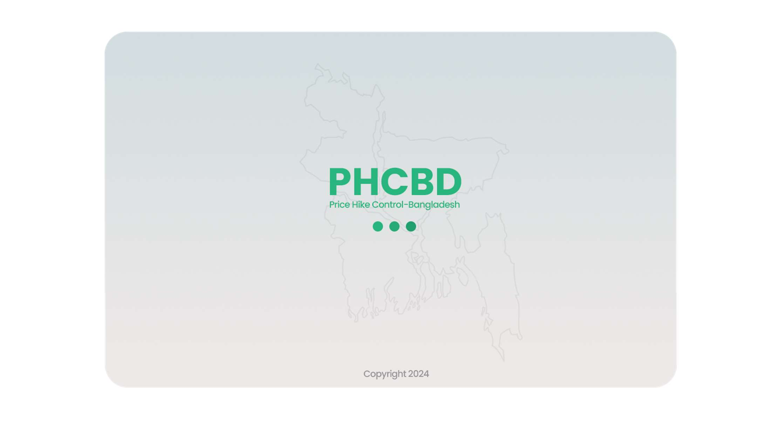

Starting Page

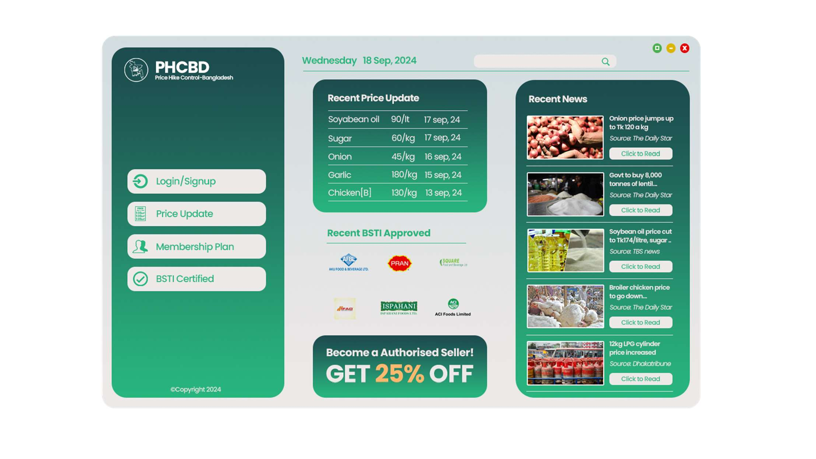

Home Page

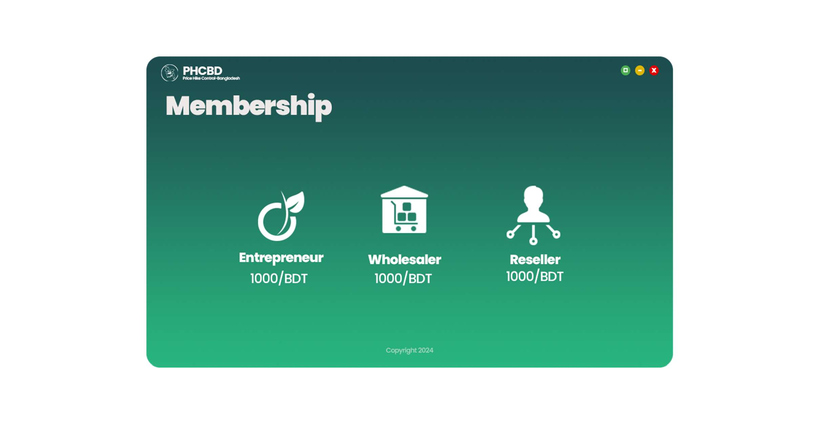

Membership Page

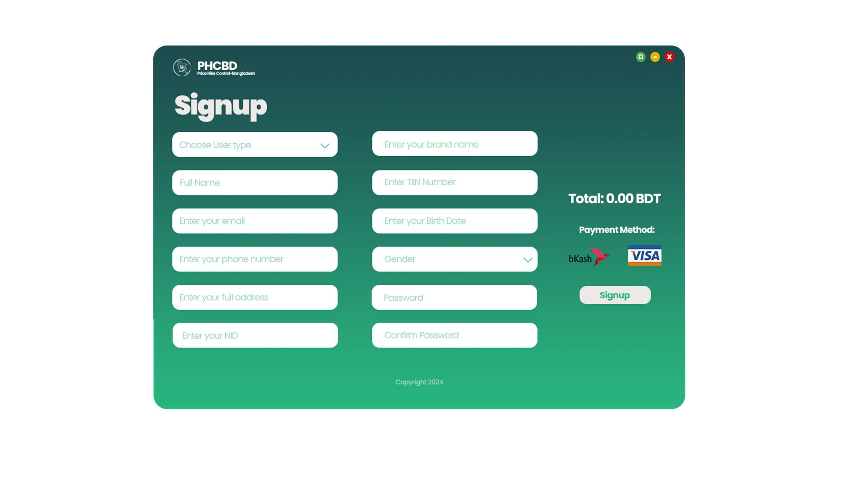

Reseller Wholesaler Entrepreneur

Signup Page

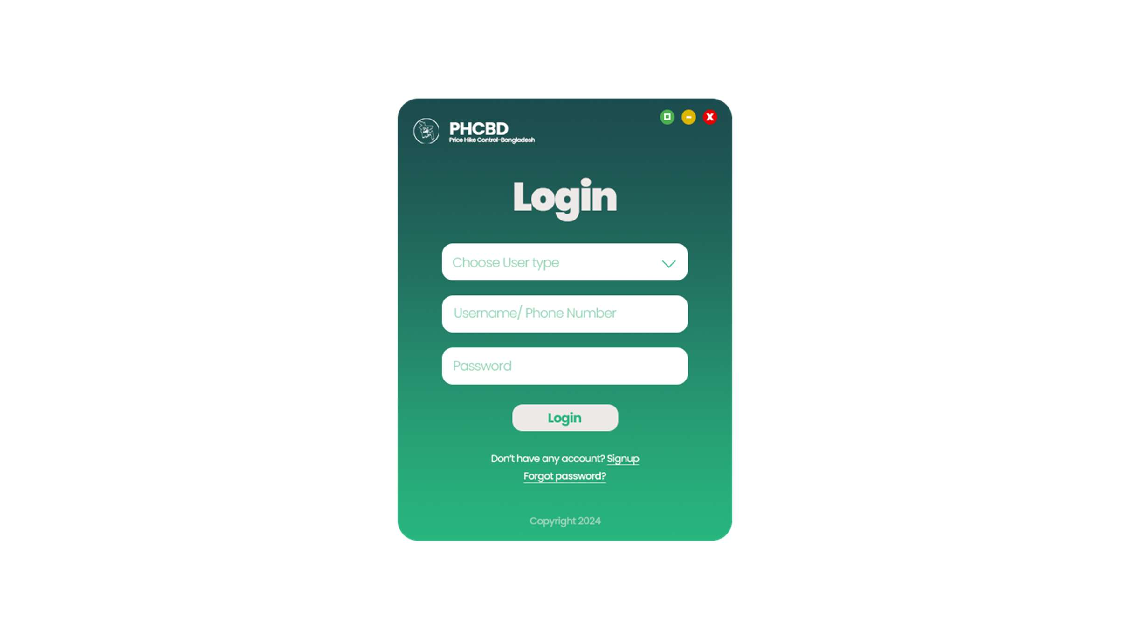

Reseller Wholesaler Entrepreneur

Login Page

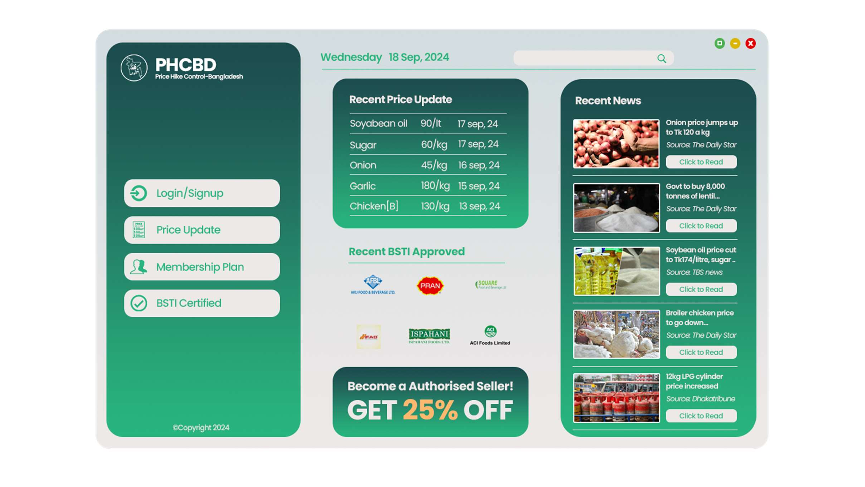

Home Page

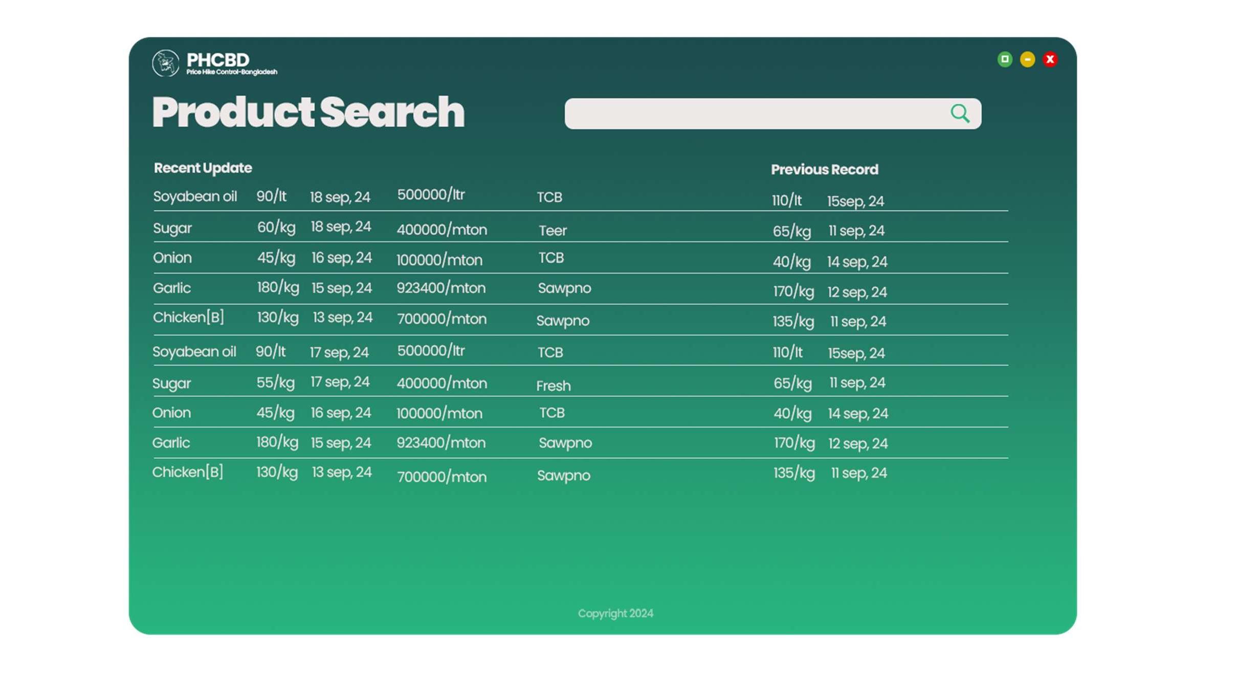

Product Search Page

Things to concern:

* **Regular Monitoring**
* **Physical Stock monitoring**
* **Reach out to mass people or Rural area**
* **Mobile App or a Responsive app needed**